**Contents**

1. Introduction 5

1.1 Overview 5

1.2 Objectives 5

1.2.1 User Authentication: 5

1.2.2 Financial Transaction Management: 5

1.2.3 Budget Monitoring and Alerts: 5

1.2.4 Data Visualization and Export: 5

1.3 Key Features 5

1.3.1 User Registration and Login: 5

1.3.2 Transaction Management: 6

1.3.3Receipt Upload and Preview: 6

1.3.4Budget Setting and Alerts: 6

1.3.5 Data Visualization: 6

1.3.6Callendar View: 6

1.3.7Theme Toggle (Dark/Light Mode): 6

1.3.8Export to CSV: 6

2. Targeted Audience 6

2.1 Targeted 6

2.2 How to use it? 7

2.2.1Signup window 7

2.2.2Login window 7

2.2.3Transaction tab 7

2.2.4View Transaction tab 8

2.2.5Budget tab 9

2.2.6Calendar view 10

2.2.7Analysis tab 10

2.3 Best case 11

3. Technology used 11

3.1 GUI framework 11

3.2 Database 11

3.3 Analysis 11

4. DBMS 12

4.1 Database used 12

4.2 CRUD Operations 12

5. Database Functioning 12

5.1 Creating database 12

5.2 Creating tables 13

5.3 Storing data 13

5.4 Retrieving data 14

5.5 Data updating for analysis 14

6. OOP 15

6.1. Classes 15

6.1.1. Database Handler 15

6.1.2. Signup 15

6.1.3. Main App 16

6.2. Constructors 16

6.2.1. Main App 16

6.2.2. Login/Signup 17

6.2.3. Database 17

6.3 Methods 18

6.3.1. Main Application 18

6.3.2. Login/Signup 18

6.3.3. Database 19

6.4. Abstraction 19

7. Run time analysis 20

7.1 Library used 20

7.2 Why Matplotlib 20

7.3 Graph description 21

7.3.1Expenses Over Time: 21

7.3.2Income Over Time: 21

7.3.3Expenses by Category: 21

7.3.4Income vs Expenses Pie Chart: 22

8. Dataflow diagram 22

8.1 Overview 22

9. Entity relationship Diagram 24

9.1 Overview 24

9.2 ERD 24

10 Relationships 25

10.1 Entities 25

10.2 Relationships 25

10.3 Strong entities 27

10.4 Weak entities 27

11. Limitations 28

11.1 Scaling 28

11.2 Deployment 28

11.3 Framework out of date 28

12. Conclusion 28

13. GitHub link 29

**Table of figures**

Figure 1: Signup 7

Figure 2: Login window 8

Figure 3: Add Transaction 8

Figure 4: View Transaction 9

Figure 5: Budget Tab 9

Figure 6: Calender Tab 10

Figure 7: Analysis tab 11

Figure 8: Create database 13

Figure 9: Create table 14

Figure 10: save data 14

Figure 11: Retreive data 15

Figure 12: DB 16

Figure 13: Signup 16

Figure 14: Mainapp 17

Figure 15: C1: Mainapp 17

Figure 16: Login - Signup 18

Figure 17: Database 18

Figure 18: Main app 19

Figure 19: Login - signup 19

Figure 20: Data Base 20

Figure 21: Abstraction 1 20

Figure 22: Abstraction 2 21

Figure 23: Expenses over time 22

Figure 24: Income over time 22

Figure 25: Expenses over category 23

Figure 26: Income vs Expenses 23

Figure 27: DFD 25

Figure 28: ERD 26

Figure 29: Relation 1 27

Figure 30: Relation 2 27

Figure 31: Relation 3 28

Figure 32: Relation 4 28

Figure 33: Relation 5 29

Figure 34: relation 6 29

Figure 35: Relation 7 30

# 1. Introduction

## 1.1 Overview

This project is a full-stack Finance Tracker with user authentication through a signup/login system built in Tkinter with MySQL as the backend database.

At first run the user can input its details while after that it only require password authentication to login the user.

Once logged in, users can add, view, edit, delete, and analyze their transactions categorized as income or expense.

The tracker also supports budgets, search filters, CSV export, receipt uploads, and monthly analysis graphs.

A dark/light theme toggle, a calendar view, and budget overspending alerts provide a modern, interactive user experience**.**

## 1.2 Objectives

### 1.2.1 User Authentication:

Implement a secure signup and login mechanism to protect user data and ensure personalized access.

### 1.2.2 Financial Transaction Management:

Allow users to add, edit, view, and delete income and expense records with category and receipt support.

### 1.2.3 Budget Monitoring and Alerts:

Enable users to set monthly budgets per category and receive alerts when spending exceeds the limit.

### 1.2.4 Data Visualization and Export:

Provide analysis tools, calendar views, and export options like CSV to help users better understand their financial habits.

## 1.3 Key Features

### 1.3.1 User Registration and Login:

Secure signup/login system with email validation and password strength checking.

### 1.3.2 Transaction Management:

Easily add, edit, delete, and search income and expense transactions with category tags.

### 1.3.3Receipt Upload and Preview:

Attach receipt images to transactions and view them directly inside the app.

### 1.3.4Budget Setting and Alerts:

Set monthly spending limits per category and get notified if you exceed your budget.

### 1.3.5 Data Visualization:

Analyze financial trends with graphs like pie charts, line charts, and category breakdowns.

### 1.3.6Callendar View:

View daily transaction summaries using an interactive, clickable calendar.

### 1.3.7Theme Toggle (Dark/Light Mode):

Switch between dark mode and light mode for a comfortable viewing experience.

### 1.3.8Export to CSV:

Download filtered transaction reports for backup or external analysis.

# 2. Targeted Audience

## 2.1 Targeted

This application is designed for individuals, freelancers, and small business owners who want an easy way to manage their finances.

It is ideal for users looking for a simple, offline, and secure personal finance management tool with rich features.

Anyone who prefers visual insights, budget tracking, and receipt organization without relying on complex or paid software will benefit from this app.

## 2.2 How to use it?

### 2.2.1Signup window

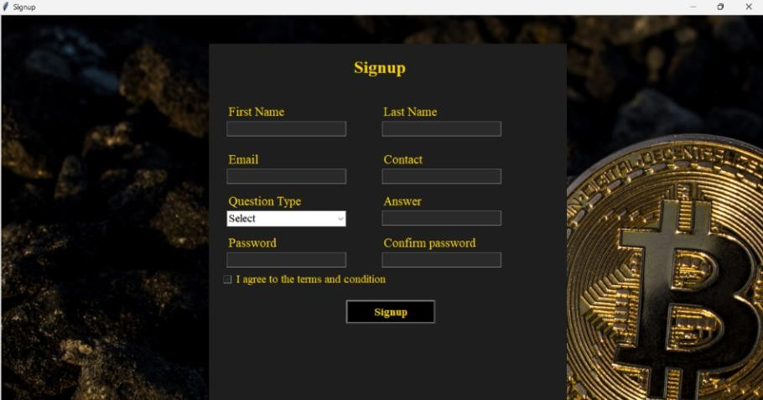

Figure : Signup

### 2.2.2Login window

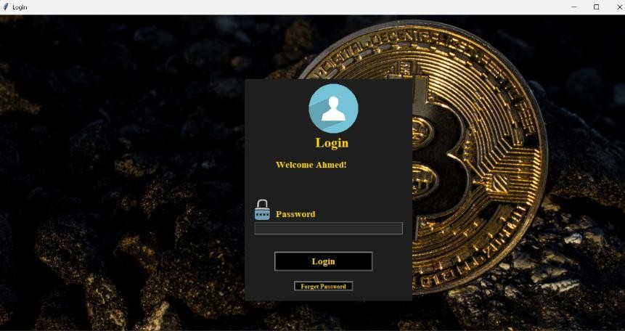

Figure : Login window

### 2.2.3Transaction tab

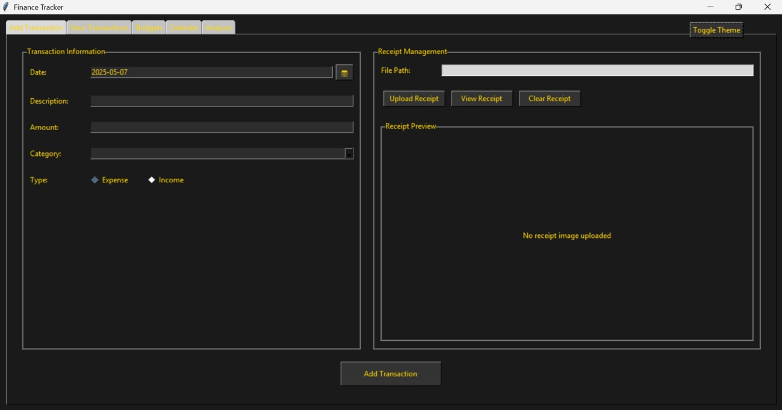

Figure : Add Transaction

### 2.2.4View Transaction tab

Figure : View Transaction

### 2.2.5Budget tab

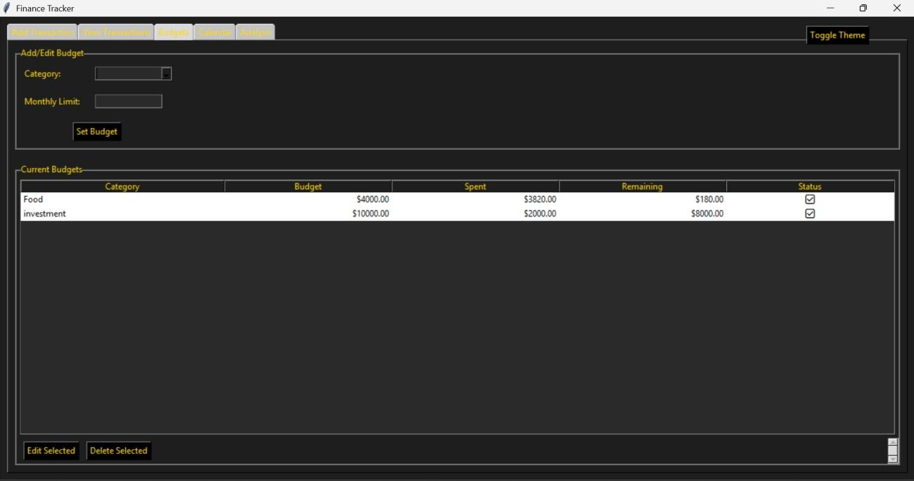

Figure : Budget Tab

### 2.2.6Calendar view

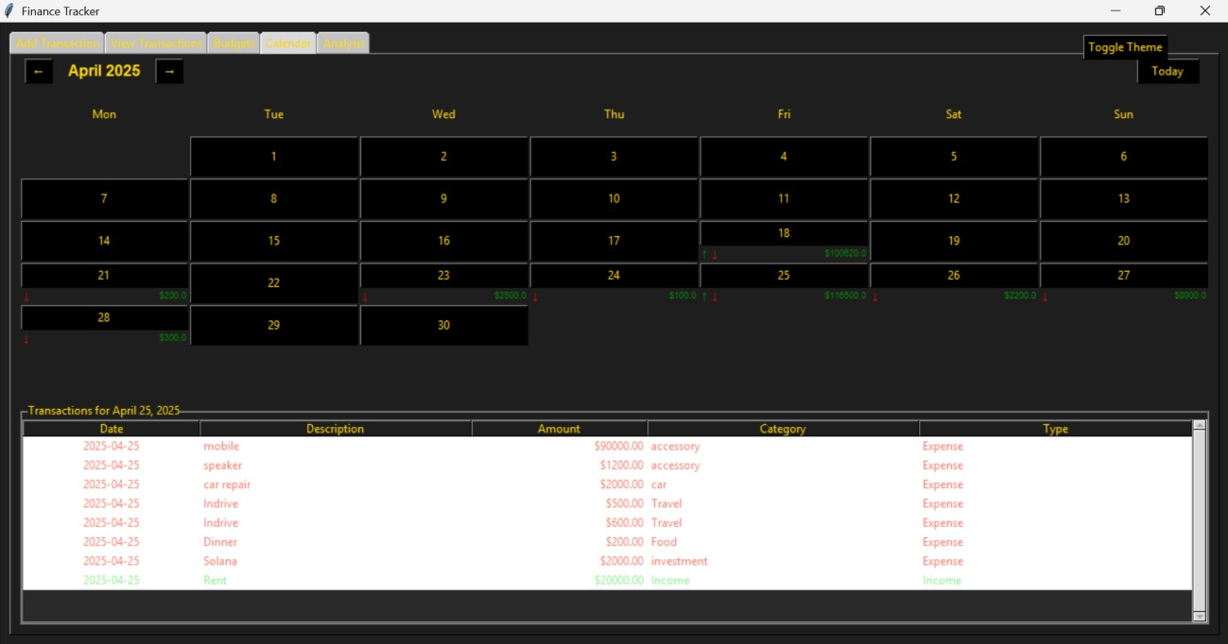

Figure : Calender Tab

### A screenshot of a computer AI-generated content may be incorrect.2.2.7Analysis tab

Figure : Analysis tab

## 2.3 Best case

This app is best used as a daily expense tracker to monitor personal or small business finances. It helps users stay within budget, analyze spending habits, and organize receipts securely in one place.

Perfect for managing monthly budgets, preparing financial reports, and maintaining better control over money flow.

# 3. Technology used

## 3.1 GUI framework

I have used tkinter in this project as a GUI framework. Tkinter is Python’s standard built-in library for creating Graphical User Interface (GUI) applications.

It provides a simple and efficient way to build windows, buttons, forms, and other interactive elements.

Tkinter is lightweight, easy to learn, and perfect for building both small and large desktop apps.

## 3.2 Database

I have used MySQL as the database in the project. MySQL is a powerful, open-source relational database management system (RDBMS) used to store and manage data.

It is highly reliable, fast, and supports structured data storage with SQL queries for creating, reading, updating, and deleting records.

MySQL is widely used in web and software applications due to its stability, scalability, and ease of integration with Python and other languages.

## 3.3 Analysis

For analysis purposes I have used Matplotlib. Matplotlib is a popular data visualization library in Python used for creating static, animated, and interactive graphs.

It helps developers plot line charts, bar graphs, pie charts, and many other types of visual data representations.

Matplotlib is highly customizable, making it perfect for creating professional and publication quality plots.

# 4. DBMS

## 4.1 Database used

I have used MySQL as the database in the project. MySQL is a powerful, open-source relational database management system (RDBMS) used to store and manage data.

It is highly reliable, fast, and supports structured data storage with SQL queries for creating, reading, updating, and deleting records.

MySQL is widely used in web and software applications due to its stability, scalability, and ease of integration with Python and other languages.

## 4.2 CRUD Operations

For CRUD operations I have used RAW SQL. It is because the queries written in the raw SQL executes faster than any ORM layer. The queries are simpler and easy to write. In my project I have used MySQL connector to write raw SQL queries. The MySQL connector provides flexibility and easy to write functions for the python program. I have written the CRUD functions in a separate file named DB.py to store all the CRUD operations written in RAW SQL.

# 5. Database Functioning

## 5.1 Creating database

The program connects to MySQL and checks if the required database exists, creating it if necessary.

This ensures all user and transaction data is organized under a dedicated database (user_registration or finance_tracker).

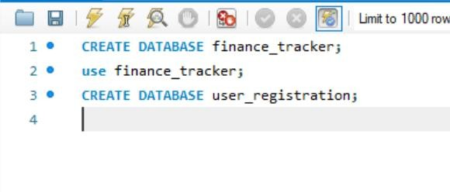

Figure : Create database

## 5.2 Creating tables

SQL commands are executed to create essential tables like users, transactions, and budgets. These tables define the structure for storing different types of data, such as user details and financial records.

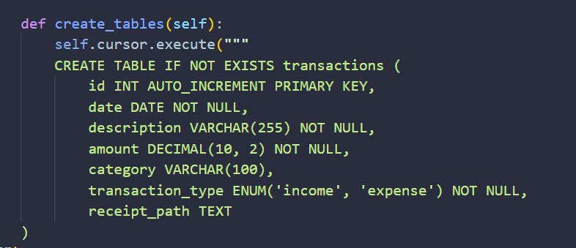

Figure : Create table

## 5.3 Storing data

User inputs like signup details and financial transactions are inserted into the database using SQL INSERT queries.

Receipts and additional information are also stored securely to ensure a complete record of each entry.

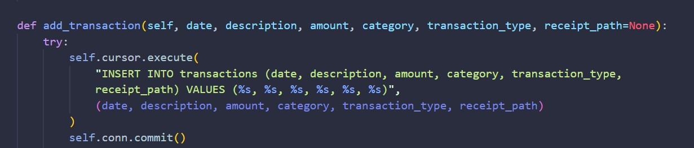

Figure : save data

## 5.4 Retrieving data

The application uses SELECT queries to fetch data for login verification, display transactions, budgets, and analysis.

Filters like date range, category, and type are applied to retrieve only the necessary information for users.

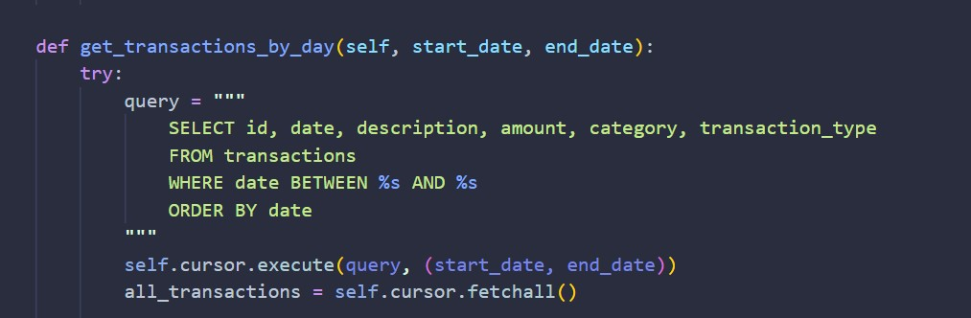

Figure : Retreive data

## 5.5 Data updating for analysis

Users can update transaction details, and budgets dynamically through SQL UPDATE queries. This updated data is immediately reflected in graphs, reports, and alerts for real-time financial analysis.

# 6. OOP

## 6.1. Classes

### 6.1.1. Database Handler

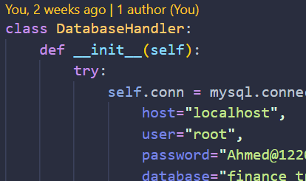

Figure : DB

### 6.1.2. Signup

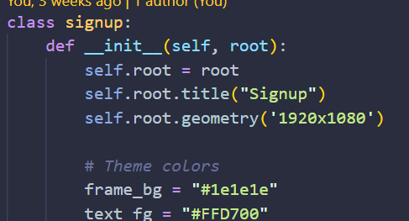

Figure : Signup

### A screen shot of a computer code AI-generated content may be incorrect.6.1.3. Main App

Figure : Mainapp

## 6.2. Constructors

### 6.2.1**. Main App**

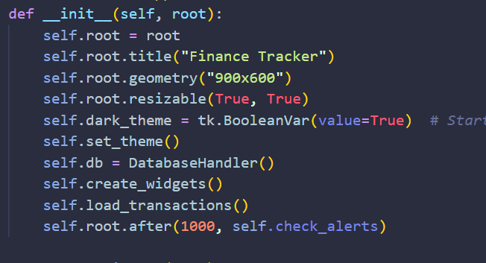

Figure : C1: Mainapp

### 6.2.2. **Login/Signup**

Figure : Login - Signup

### 6.2.3. Database

Figure : Database

## 6.3 Methods

### 6.3.1. Main Application

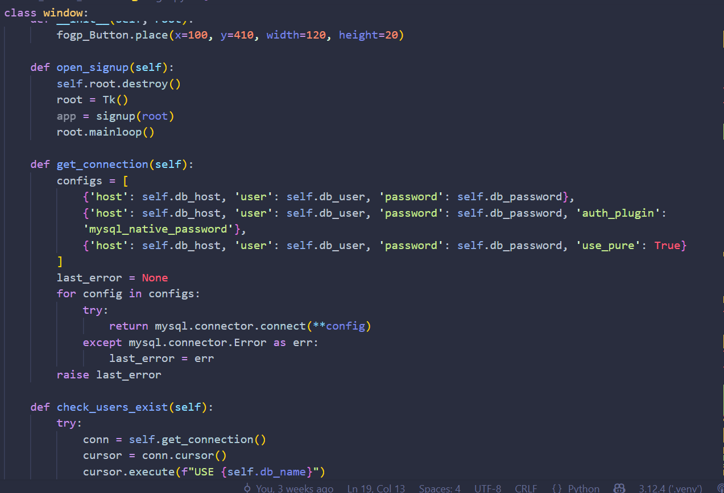

Figure : Main app

### 6.3.2. Login/Signup

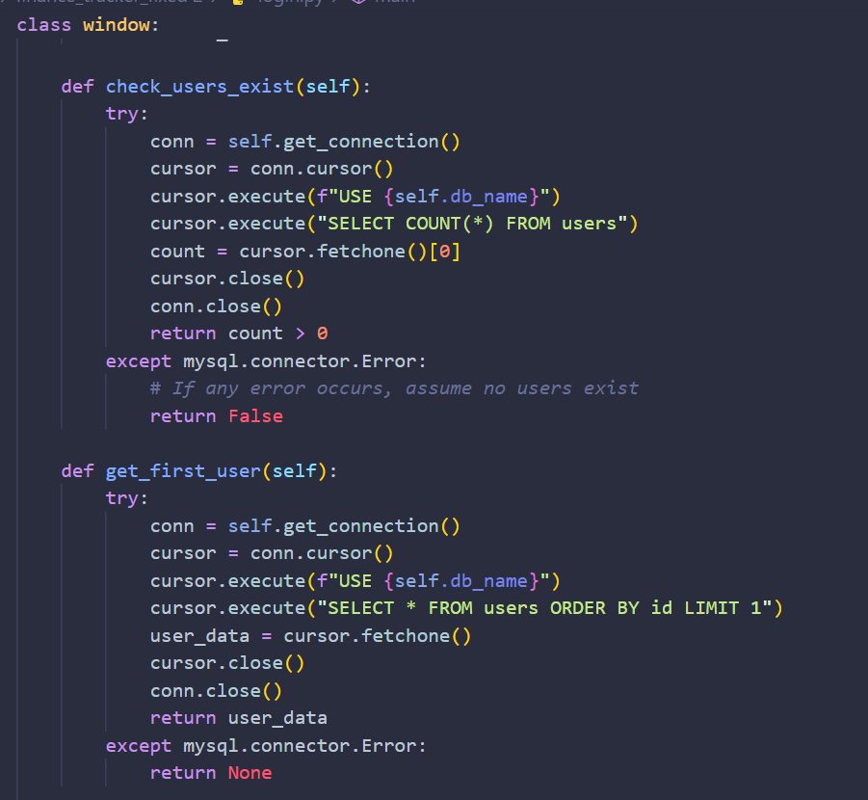

Figure : Login - signup

### 6.3.3. Database

Figure : Data Base

## 6.4. Abstraction

I have created a separate file to run the main function the file serves as the function calling that calls the functions of the main app. The root and the main window is main looped here.

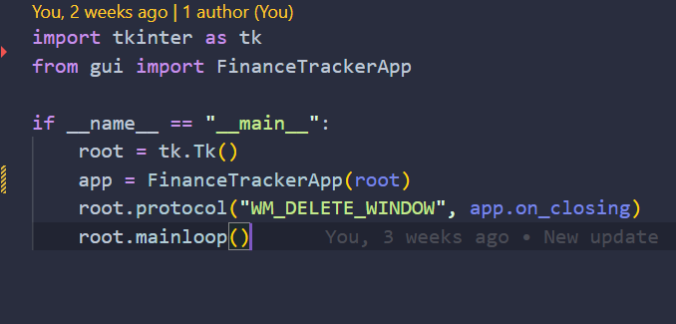

Figure : Abstraction 1

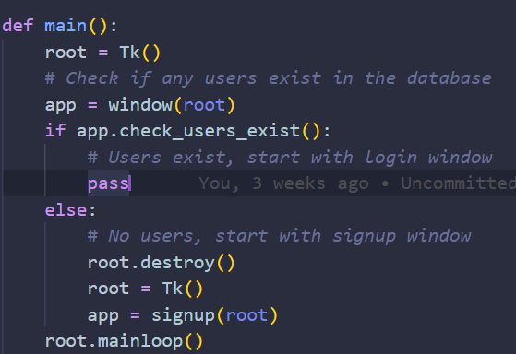

Figure : Abstraction 2

# 7. Run time analysis

## 7.1 Library used

For analysis purposes I have used Matplotlib.

## 7.2 Why Matplotlib

Matplotlib is a popular data visualization library in Python used for creating static, animated, and interactive graphs.

It helps developers plot line charts, bar graphs, pie charts, and many other types of visual data representations.

Matplotlib is highly customizable, making it perfect for creating professional and publication quality plots.

## 7.3 Graph description

### 7.3.1Expenses Over Time:

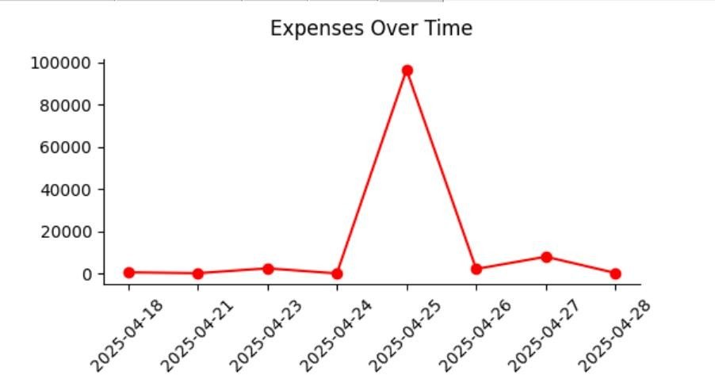

Figure : Expenses over time

### 7.3.2Income Over Time:

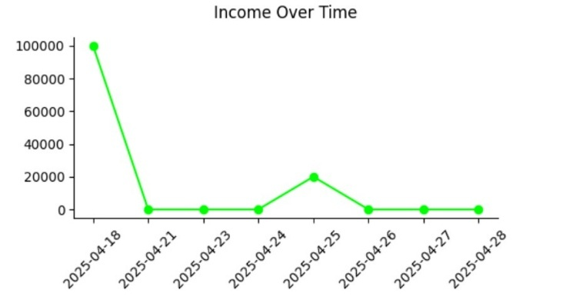Figure : Income over time

### 7.3.3Expenses by Category:

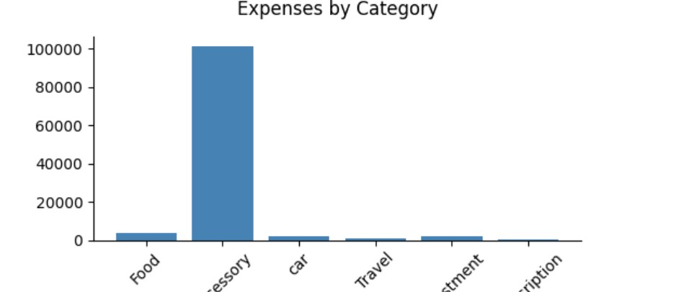

Figure : Expenses over category

### 7.3.4Income vs Expenses Pie Chart:

Figure : Income vs Expenses

# 8. Dataflow diagram

## 8.1 Overview

This diagram shows the flow of a financial management app where users can sign up, log in, and access the main app. From the main app, users can add transactions, view transactions, set budgets, view analysis, and access a calendar view. All transaction, budget, and analysis data are stored and retrieved from a central database.

The app also incorporates an alert system that notifies users when they approach or exceed budget limits based on their transaction history. Users can customize notification preferences and set personalized financial goals with progress tracking features. The system includes machine learning capabilities that provide spending pattern insights and future expense predictions. Additionally, the app offers bill payment reminders and recurring transaction automation to help users maintain financial discipline. For security, the platform implements multi-factor authentication and end-to-end encryption to protect sensitive financial data.

**8.2 DFD**

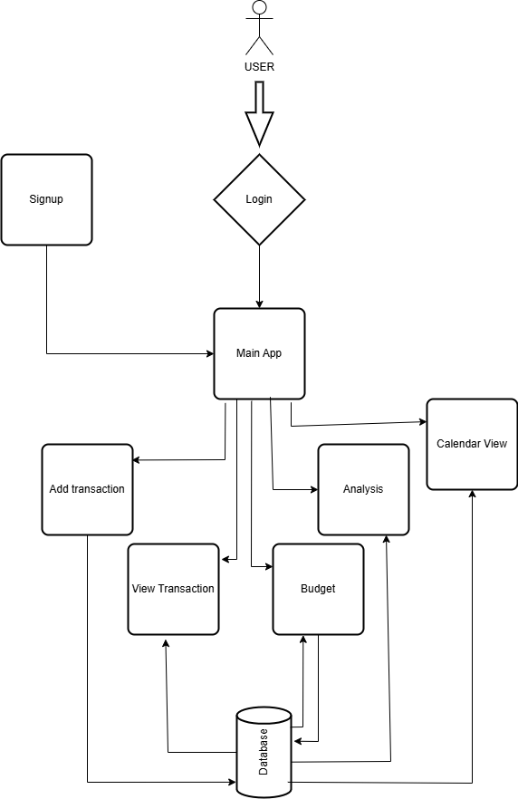

Figure : DFD

# 9. Entity relationship Diagram

## 9.1 Overview

This ERD represents a system with three entities: User, Transaction, and Budget. Users have personal details and are linked to multiple transactions, while transactions are categorized and can relate to budgets. Budgets define spending limits for specific categories and are connected back to transactions through the category field.

## 9.2 ERD

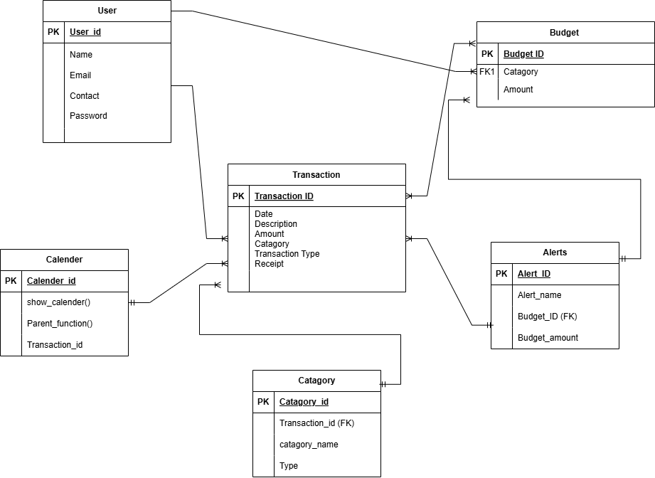

Figure : ERD

# 10 Relationships

## 10.1 Entities

In my project, the main entities are **User**, **Transaction**, and **Budget**, each represented by a table in the database.

## 10.2 Relationships

The User entity is related to Transaction — meaning a user (after login) can add/view/edit multiple transactions; similarly, Budgets relate to transaction categories.

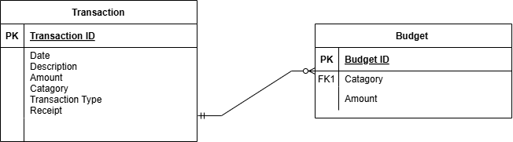

Figure : Relation 1

This ERD shows a one-to-many relationship where each transaction belongs to a category, but the model is incorrectly structured — the Category table should not have a foreign key to Transaction. Instead, Transaction should reference Categorified as a foreign key.

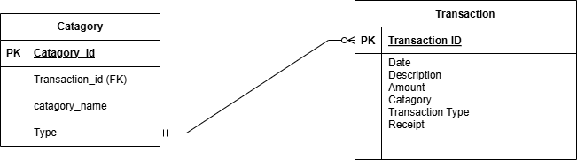

Figure : Relation 2

This ERD shows a one-to-many relationship where each calendar entry is linked to a transaction. However, functions like show_calender() and Parent_function() should not be attributes in an ERD, as ERDs only model data, not behavior.

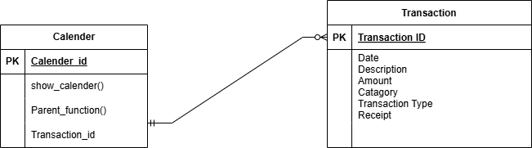

Figure : Relation 3

This ERD shows a relationship between "Alerts" and "Transaction" entities. The Alerts table has a primary key of Alert_ID and contains fields for Alert_name, Budget_ID (a foreign key), and Budget_amount. It has a many-to-one relationship with the Transaction table, which has Transaction_ID as its primary key and includes fields for Date, Description, Amount, Category, Transaction Type, and Receipt.

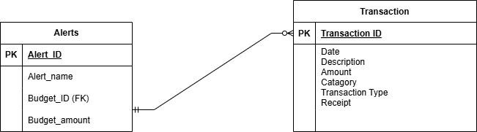

Figure : Relation 4

This ERD illustrates a relationship between "Alerts" and "Budget" entities. The Alerts table contains Alert_ID (primary key), Alert_name, Budget_ID (foreign key), and Budget_amount fields. It has a many-to-one relationship with the Budget table, which has Budget_ID as its primary key and includes Category (FK1) and Amount fields. This structure allows multiple alerts to be associated with a single budget.

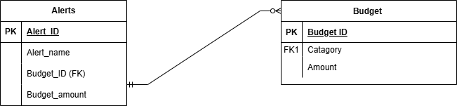

Figure : Relation 5

## 10.3 Strong entities

User, Transaction, and Budget are all strong entities because they each have their own primary keys (id) and can exist independently.

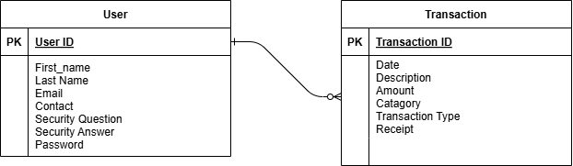

Figure : relation 6

## 10.4 Weak entities

Your project does not use weak entities because all records are uniquely identifiable on their own without needing a composite key or dependency.

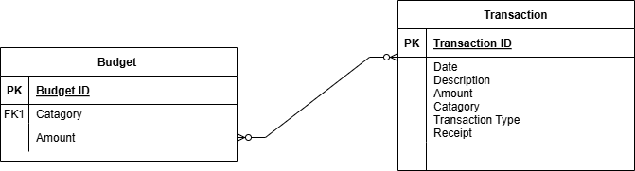

Figure : Relation 7

# 11. Limitations

## 11.1 Scaling

The project is designed for individual or small business use; handling many users or massive transaction data would require upgrading to a more scalable backend (e.g., using connection pooling, ORM, or cloud databases).

## 11.2 Deployment

Since it is built with Tkinter (a desktop-only GUI) and local MySQL, it is not web-based and needs manual installation on each machine where it’s used.

## 11.3 Framework out of date

Tkinter, while stable, is limited in modern UI features compared to newer frameworks (like PyQT, Flutter, or web apps), making it harder to deliver a sleek, mobile-friendly or highly interactive experience.

# 12. Conclusion

In conclusion, this project successfully demonstrates how personal finance management can be made simple and user-friendly. The application provides users with a secure way to register, log in, and manage their financial transactions efficiently. By offering features like budgeting, calendar views, receipt uploads, and data analysis graphs, it covers essential financial needs. The use of Tkinter ensures a clean and responsive interface, while MySQL provides a reliable backend for storing critical data. Real-time alerts and detailed analysis help users make better financial decisions and control overspending. Although the application is designed for smallscale usage, it lays a strong foundation for future scalability. It also shows good coding practices by separating database operations, GUI design, and application logic into different modules. Challenges like database handling and file management were overcome with effective solutions and thorough testing. There is still room for improvements, such as deploying the app to the web or adding more intelligent reporting features. Overall, this project achieves its goal of delivering a complete, offline finance tracking system with modern user experience.

# 13. GitHub link

You can find the complete source code for this project on GitHub.

Visit the repository here: https://github.com/ahmed-jawad-5/finance_tracker.git